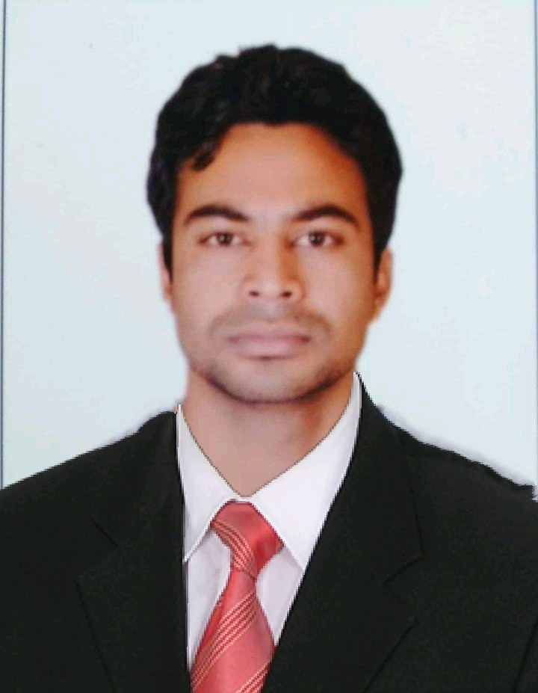
CURRICULUM VITAE
MOHD RAMEEZ REZA
+919137369477
rameez.reza01@gmail.com
Position:
Career Objective: Have an in depth knowledge of civil engineering principles and theories. Seeking for a challenging position as a Civil Engineer, where I can use my planning, designing and overseeing skills in construction and help grow the company to achieve its goal.
Educational Qualification:
Bachelor of Technology (Civil Engineering) from Mangalayatan University, India
Intermediate from NIOS India
Matriculation from AMU India

Professional Experience:
- Civil Site Engineer, 15th Jan 2018 to till Date M3M India Pvt Ltd.
- Civil Supervisor, 05 April 2017 to 10 January 2018 FINEHOPE ALLIED CONSTRUCTION (INDIA) PVT. LTD.
- Supervisor, 12th May 2015 to 05 March 2017 ALP BUILDTECH PVT.LTD.
- Six weeks training in ASTRAL ASSOCIATES PVT. LTD. from 8th June 2014 to 20th July 2014

Duties and responsibility:
- Supervision of all works in construction.
- Controlling manpower of material & equipment.
- Execute the work as per drawings and standards both discipline (Structural, Architectural Works)
- Supervision for frame structure from work, Steel work, and concrete as per approved design.
- Checking the quality of RCC works such as Foundation,Columns,Beam,Walls and slabs etc.
- Finishing work (Block work, Brick Work and Plaster work and also Tiles work).
- Site Architectural Layout regarding Block work, Door-windows, Floor levels, Lintel and stiffeners.
- Checking the quality of steel and Grade of concrete as per structural requirement, diameter shape and cement.
- Prepared BBS(Bar-Binding Schedule)
- Preparing Daily, Weekly, monthly, reports on work Progress Reports (key performance indicator) & evaluating as per the planned schedules.
- Supervision of all works in construction.
- Controlling manpower of material & equipment.
- Attending the client meeting regarding the status of work.
- Coordination with consultant and Project Manager regarding work and inspection.
- Take action and follow the instruction of consultant and Project Manager.
- Responsible for maintaining overall quality of a construction project. Always ensure the work is done as per standard construction procedures.
- Responsible to implement company policies, government policies and other policies related to construction.
- Maintaining timely-finish task according to schedule.
- Sub-contractor handling: Responsible to continually monitor sub-contractors performance and make them understand company policy and operating procedure.
- Cost controlling: Identifying variances and reducing wastage by effective management.
- Maintaining work environment: By following and enforcing standard procedures and regulations, to keep the work environment secure, safe and healthy.

Technical Skills:
- Operating systems: Windows 7 , 8 and 8.1 , Android , Mac OSX
- Software Known- AutoCAD, MS Office (Word, Excel)
Personal Skills:
• Good social skills and understanding.
• Have profound curiosity in learning new things.
• Cooperative, Socially adaptable and friendly.
Personal Details:
Father Name: Mohd Manir Reza
Nationality: Indian
Marital Status: Unmarried
Date of Birth: 19th September 1994
Permanent Address: At- Jhumka, Sikta, West Champaran, Bihar
Language: English, Hindi
Passport Details:
Passport No.: N2233277
Issue Date: 04/08/2015
Exp. Date: 03/08/2025
Passport type: ECNR
Passport issue place: PATNA

Signature
Mohd Rameez Reza

